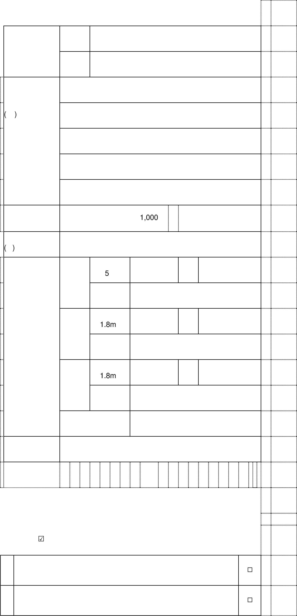

|  |  |  |  |  |  |  |  |  |  |
| --- | --- | --- | --- | --- | --- | --- | --- | --- | --- |
|  | ※ |  | |  | □ | | |  |  |
|  | ※ |  | |  | □ | | |  |  |
|  |  | |  | □ | |  |  |  |
|  |  |  | □ |  |  |  |
|  |  | □ |  |  |
|  | |  | □ | |  |  |
|  | |  | □ | |  |  |
|  |  |  | |  | □ | | |  |  |
|  |  | 1.8 | | 5 | □ | | |  |  |
|  |  |  | |  | □ | | |  |  |
|  | ※ |  | |  | □ | | |  |  |
|  |  |  | |  | □ | | |  |  |